St. Joseph’s Secondary School

Newfoundwell, Drogheda, Co. Louth

Privacy Notice
for Students, Staff, BoM, Parents and Guardians

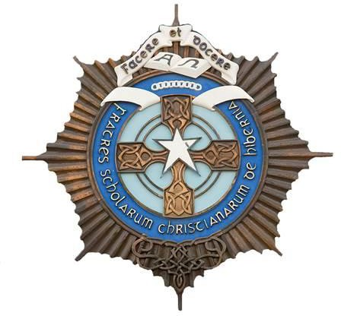

School Details: St. Joseph’s Secondary School is a Voluntary Roman Catholic Secondary School under the Trusteeship and the Patronage of the Edmund Rice Schools Trust. The School is grant aided by the Department of Education & Skills and is a single sex (boys) school.
School Management: The Board of Management of St. Joseph’s Secondary School is a statutory Board appointed pursuant to the provisions of the Education Act 1998.

Mission Statement
St. Joseph’s Secondary school recognises that each pupil who enrols in our school is unique and has different gifts as well as different needs. It is our wish that our pupils will leave us with enhanced self-confidence and with life skills and attitudes which will enable them to lead lives satisfying to themselves and which may contribute to the betterment of society.
We recognise that a pupil’s development is closely linked to a good self-image and so we strive to present the school’s total curriculum in such a manner as to allow all to realise their full potential.
We see ourselves as working in partnership with parents to develop the different gifts and to meet the needs of all. We regard our school as an educational establishment with a Christian community characterised by care and justice.

Ethos
As an Edmund Rice School, St. Joseph’s seeks to promote the five key elements of an Edmund Rice School as espoused by the ERST Charter:
- Nurturing faith, Christian spirituality and Gospel-based values
- Promoting partnership in the school community
- Excelling in teaching and learning
- Creating a caring school community
- Inspiring transformational leadership.

Introduction
By enrolling in and attending St. Joseph’s Secondary School, the student and his parents/guardians acknowledge that personal data will be processed by the school. This Privacy Notice provides information about what personal data is collected, why it is collected, with whom it is shared and why, retention periods and the rights of the individual under General Data Protection Regulation (GDPR).
The St. Joseph’s Data Protection Policy and St. Joseph’s GDPR page can be found on www.droghedacbs.ie

- What information is collected?
St. Joseph’s needs and uses personal data of all students. The personal data collected can include information about identity and contact details: images/photos, CCTV footage, family details, admission/enrolment details, previous schools, academic progress, PPS number, additional educational needs, nationality, language, religion, medical data, information about behaviour and attendance, information about health, safety and welfare, financial information (regarding fees and grants) and other personal data.

If a student is under 18 years when enrolled, the school collects the name, address, contact details and other information about the parents/guardians. Also, parents/guardians are consulted and asked to give consent for certain things like taking of photographs, going on school trips etc.

How is the information used?
Personal data is used for normal day to day school operations and for purposes including:

- application for enrolment
- to provide appropriate education and support
- to monitor academic progress
- to care for health and well-being
- to care for staff and students
- to process grant applications and fee payments
- to coordinate, evaluate, fund and organise educational programmes
- to comply with legal obligations as an education body
- to comply with monitoring and reporting obligations to Government bodies
- to process appeals, defend against litigation, resolve disputes, etc.

With whom is the information shared?
The school shares personal data with third parties, including Government bodies. This includes:

- Department of Education and Skills (DES)
- State Examinations Commission (SEC)
- National Council for Special Education (NCSE)
- Child and Family Agency, TUSLA
- An Garda Síochána
- Health Service Executive (HSE)
- Department of Social Protection.

The level of sharing and the nature of what is shared depends on various factors. The Government bodies to which the school transfers personal data will use personal data for their own purposes (including verifying other information they already hold, etc.) and they may aggregate it with other information they already hold. The school also shares personal data with third parties including the insurance company and other service providers e.g. IT providers, security providers, legal advisors etc. The school is legally required to provide certain records relating to the progress of a student (under 18 years) in his education to the student’s parents/guardians, including results of examinations.

We do not transfer your personal data to a third country or international organisation.

We do not engage in automated decision making/profiling.

How long is data held?
Some personal data is only kept for a short period and will be destroyed at the end of an academic year because it is no longer needed. Some data is retained for longer periods, including after a student leaves St. Joseph’s.

What are an individual’s statutory rights?
Every individual has the:
- Right to be informed
- Right to access information
- Right to rectification
- Right to erasure
- Right to data portability
- Right to object to processing of personal data
- Right of restriction
- Right to not be subject to a decision based solely on automated processing.

Contact
Queries relating to this Privacy Notice can be relayed to the school office at cbsoff2015@gmail.com .

Approval
This Privacy Notice has been approved by St. Joseph’s Secondary School Board of Management.

Signed: Date:

Chairperson, Board of Management

